To configure SNMPv3 on a Cisco switch
To configure SNMPv3 on a Cisco switch, follow these steps. SNMPv3 is a secure version of SNMP (Simple Network Management Protocol) that supports authentication and encryption, making it ideal for environments that require secure network monitoring.
1. Configure SNMPv3 User and Group
- Define an SNMPv3 group.
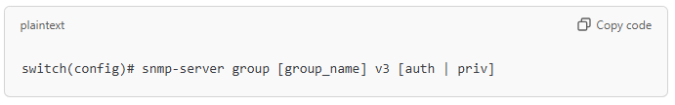
- auth: Requires authentication but no encryption.
- priv: Requires both authentication and encryption.
- Create an SNMPv3 user and assign it to the group.
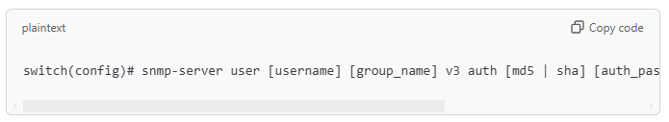
- auth_password: Authentication password (minimum of 8 characters).
- priv_password: Encryption password (only needed if priv is specified).
For example:
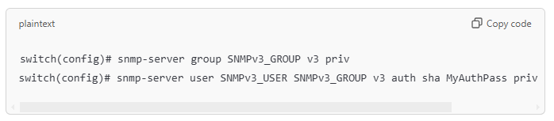
2. Configure Access Control
(Optional) Restrict access to SNMP by specifying permitted IP ranges:
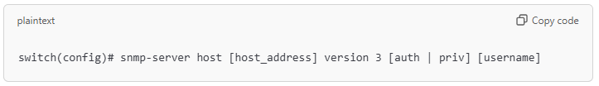

3. Enable SNMP Traps
(Optional) You can enable SNMP traps to receive notifications for specific events:
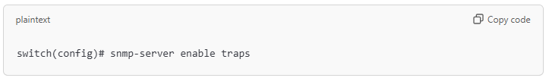
4. Verify Configuration
To check the SNMPv3 configuration, use the following commands:
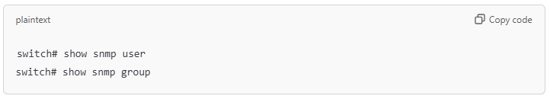
This setup should allow secure communication with SNMPv3 on your Cisco switch, using authentication and optional encryption based on your configuration.

